**The predicted data and actual data during the period from 2008 to 2019**

2008

Predicted_2008_ONI_data=[-1.59580449,-1.46228181,-1.14060985,-0.82203713,-0.59709808,-0.39691148,-0.13518662,0.1228393,0.20460761,0.01647797,-0.33169975,-0.57737911]

Actual_2008_ONI_data=[-1.6,-1.4,-1.2,-0.9,-0.8,-0.5,-0.4,-0.3,-0.3,-0.4,-0.6,-0.7]

2009

Predicted_2009_ONI_data=[-8.05374447e-01,-8.06648318e-01,-5.34687331e-01,9.86073166e-04,5.93737464e-01,1.07295251e+00,1.40609948e+00,1.64446810e+00,1.82357622e+00,1.90076942e+00,1.78989483e+00,1.46523613e+00]

Actual_2009_ONI_data=[-0.8,-0.7,-0.5,-0.2,0.1,0.4,0.5,0.5,0.7,1.0,1.3,1.6]

2010

Predicted_2010_ONI_data=[1.55743377,1.3182525,1.09763695,0.70297948,0.02142704,-0.74120587,-1.2257248,-1.38218993,-1.33461861,-1.17484555,-0.98021823,-0.79320184]

Actual_2010_ONI_data=[1.5,1.3,0.9,0.4,-0.1,-0.6,-1.0,-1.4,-1.6,-1.7,-1.7,-1.6]

2011

Predicted_2011_ONI_data=[-1.25483857,-0.71947104,-0.46079495,-0.21563322,-0.07075846,-0.06098047,-0.1516816,-0.29596786,-0.45059081,-0.55621951,-0.57347156,-0.53890072]

Actual_2011_ONI_data=[-1.4,-1.1,-0.8,-0.6,-0.5,-0.4,-0.5,-0.7,-0.9,-1.1,-1.1,-1.0]

2012

Predicted_2012_ONI_data=[-0.81865262,-0.74970965,-0.6766997,-0.54229593,-0.35601942,-0.15900659,0.00811796,0.12994266,0.20618861,0.23416366,0.20915701,0.13852284]

Actual_2012_ONI_data=[-0.8,-0.6,-0.5,-0.4,-0.2,0.1,0.3,0.3,0.3,0.2,0.0,-0.2]

2013

Predicted_2013_ONI_data=[-0.37043245,-0.3804086,-0.37636245,-0.42019557,-0.49390809,-0.55668506,-0.58711052,-0.58715291,-0.55886843,-0.49961037,-0.42409674,-0.36752787]

Actual_2013_ONI_data=[-0.4,-0.3,-0.2,-0.2,-0.3,-0.3,-0.4,-0.4,-0.3,-0.2,-0.2,-0.3]

2014

Predicted_2014_ONI_data=[-0.35270896,-0.26366526,-0.08726341,0.07767712,0.16348569,0.22249183,0.32873771,0.45504803,0.53608644,0.55891923,0.55442509,0.54811581]

Actual_2014_ONI_data=[-0.4,-0.4,-0.2,0.1,0.3,0.2,0.1,0.0,0.2,0.4,0.6,0.7]

2015

Predicted_2015_ONI_data=[0.6471787,0.59871853,0.74386575,1.09002976,1.48106207,1.63434431,1.43155453,1.07142175,0.98681175,1.14512161,1.10975078,0.84867126]

Actual_2015_ONI_data=[0.6,0.6,0.6,0.8,1.0,1.2,1.5,1.8,2.1,2.4,2.5,2.6]

2016

Predicted_2016_ONI_data=[ 2.25015097,1.96793829,1.39737285,0.83895748,0.4881617,0.27141112,0.10620102,-0.09243051,-0.36919386,-0.66663392,-0.8775558,-0.89634928]

Actual_2016_ONI_data=[2.5,2.2,1.7,1.0,0.5,0.0,-0.3,-0.6,-0.7,-0.7,-0.7,-0.6]

2017

Predicted_2017_ONI_data=[-0.41843241,-0.21173347,-0.10744654,0.01122552,0.09052058,0.10752269,0.0299614,-0.11605551,-0.27297099,-0.38896946,-0.43848105,-0.41161876]

Actual_2017_ONI_data=[-0.3,-0.1,0.1,0.3,0.4,0.4,0.2,-0.1,-0.4,-0.7,-0.9,-1.0]

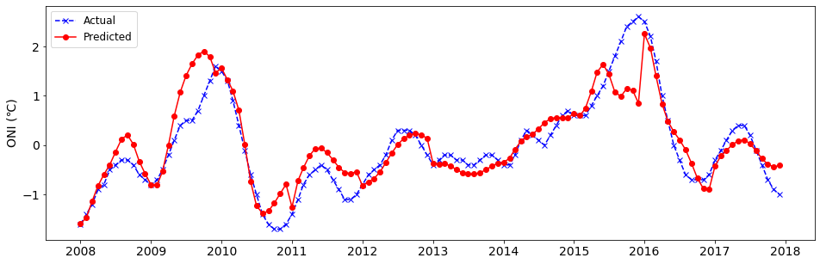

**2018**

actual_values_2018=[-0.9,-0.8,-0.6,-0.4,-0.1,0.1,0.1,0.2,0.4,0.7,0.9,0.8]

predicted_values_2018=[-0.9138631,-0.64577143,-0.46778013,-0.41380659,-0.29520753,-0.01224175,0.26282753,0.38837113,0.51434888,0.69200458,0.78456772,0.7583482]

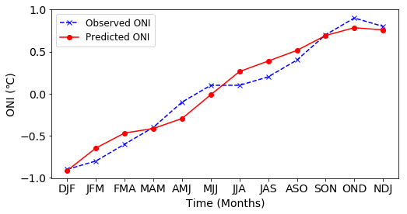

**2019**

actual_values_2019=[0.8,0.8,0.8,0.8,0.6,0.5,0.3,0.1,0.1,0.3]

predicted_values_2019_10=[0.72206478,0.66982326,0.60327048,0.38359194,0.06235942,-0.19763338,-0.28833364,-0.2525634,-0.21255207,-0.22334125]

